A Project Report

on

***ATTENDANCE MONITORING USING FACE RECOGNITION THROUGH IOT***

*Submitted for the partialfulfillment ofthe requirement for theaward of the Degreeof*

***Bachelor Of Technology***

In

***Computer Science & Engineering***

by

**Amber Singhal(160102280)**

**RitikaAssudani(160102111)**

**SrishtiDeori(160102097)**

**VaishaliBisht(160102296)**

Under theGuidanceof

**Dr. Kaushik Ghosh**

Assistant Professor

Computer Science & Engineering

DIT University,Dehradun



**DIT UNIVERSITY, DEHRADUN, INDIA**

April’2019

A Project Report

on

***ATTENDANCE MONITORING USING FACE RECOGNITION THROUGH IOT***

*Submitted for the partialfulfillment ofthe requirement for theaward of the Degreeof*

***Bachelor Of Technology***

In

***Computer Science & Engineering***

by

**Amber Singhal(160102280)**

**RitikaAssudani(160102111)**

**SrishtiDeori(160102097)**

**VaishaliBisht(160102296)**

Under theGuidanceof

**Dr. Kaushik Ghosh**

Assistant Professor

Computer Science & Engineering

DIT University,Dehradun



**DIT UNIVERSITY, DEHRADUN, INDIA**

April’2019



**DECLARATION**

Thisistocertify thattheProjectentitled **“Attendance Monitoring Using Face Recognition Through IOT”**inpartialfulfillmentof therequirement fortheawardofthe**DegreeofBachelor of Technology**in**Computer Science & Engineering**,submitted to**DITUniversity, Dehradun,Uttarakhand,India,**is anauthenticrecordofbonafideworkcarried out byme, under the guidanceof **Dr. Kaushik Ghosh.**

The matter embodiedinthisProject/Thesis/Dissertationhasnotbeensubmitted forthe award ofanyother degreeor diplomato anyUniversity/Institution.

|  |  |  |
| --- | --- | --- |
| **Students Name & Signature:** |  | **Supervisor Name , Designation & Signature:** |
| Amber Singhal  RitikaAssudani  SrishtiDeori  VaishaliBisht |  | Dr. Kaushik Ghosh  Assistant Professor,  Computer Science & Engineering,  DIT University,Dehradun |
|  |  |  |
|  |  |  |
|  |  |  |
| **Dr. Vishal Bharti**  **Head of Department**  **Signature** |  |  |

***Date:29/04/2019***

***Place: Dehradun***

iii



**CERTIFICATE**

Thisistocertify thattheProjectentitled **“Attendance Monitoring Using Face Recognition Through IOT”** in partial fulfillment oftherequirement fortheawardofthe**DegreeBachelor of Technology**in**Computer Science & Engineering**,submitted to**DITUniversity,Dehradun, Uttarakhand,India,**is anauthenticrecord ofbonafideresearchworkcarriedout by**Mr. Amber Singhal**(160102280) ,under mysupervision/guidance.

**SignatureandNameof**

**Supervisor(s)/Guide**

**Dr. Kaushik Ghosh**

Assistant Professor

Computer Science & Engineering

DIT University, Dehradun

***Date:29/04/2019***

***Place: Dehradun***

iv



**CERTIFICATE**

Thisistocertify thattheProjectentitled **“Attendance Monitoring Using Face Recognition Through IOT”** in partial fulfillment oftherequirement fortheawardofthe**DegreeBachelor of Technology** in **Computer Science & Engineering**,submitted to**DITUniversity,Dehradun, Uttarakhand,India,**is anauthenticrecord ofbonafideresearchworkcarriedout by**Ms. RitikaAssudani**(160102111) under mysupervision/guidance.

**SignatureandNameof**

**Supervisor(s)/Guide**

**Dr. Kaushik Ghosh**

Assistant Professor

Computer Science & Engineering

DIT University, Dehradun

***Date:29/04/2019***

***Place: Dehradun***

v



**CERTIFICATE**

Thisistocertify thattheProjectentitled **“Attendance Monitoring Using Face Recognition Through IOT”** in partial fulfillment oftherequirement fortheawardofthe**DegreeBachelor of Technology** in **Computer Science & Engineering**,submitted to**DITUniversity,Dehradun, Uttarakhand,India,**is anauthenticrecord ofbonafideresearchworkcarriedout by**Ms. SrishtiDeori**(160102097)under mysupervision/guidance.

**SignatureandNameof**

**Supervisor(s)/Guide**

**Dr. Kaushik Ghosh**

Assistant Professor

Computer Science & Engineering

DIT University, Dehradun

***Date:29/04/2019***

***Place: Dehradun***

vi



**CERTIFICATE**

Thisistocertify thattheProjectentitled **“Attendance Monitoring Using Face Recognition Through IOT”** in partial fulfillment oftherequirement fortheawardofthe**DegreeBachelor of Technology** in **Computer Science & Engineering**,submitted to**DITUniversity,Dehradun, Uttarakhand,India,**is anauthenticrecord ofbonafideresearchworkcarriedout by,**Ms. VaishaliBisht**(160102296)under mysupervision/guidance.

**SignatureandNameof**

**Supervisor(s)/Guide**

**Dr. Kaushik Ghosh**

Assistant Professor

Computer Science & Engineering

DIT University, Dehradun

***Date:29/04/2019***

***Place: Dehradun***

vii

**ACKNOWLEDGEMENT**

We take this opportunity to express our profound gratitude and deep regards to everyone who has helped us in completing this project.  We have taken efforts in this project. However, it would not have been possible without the kind support and help of many individuals and organizations and we would like to extend our sincere thanks to all of them.

We are highly indebted to Dr. Kaushik Ghosh for his guidance and constant supervision as well as for providing necessary information regarding the project & also for his support in completing the project. We are wholeheartedly thankful to him for giving us his valuable time, attention and for providing us a systematic way for completing our project in time.

We must make special thanks to our H.O.D. Dr. Vishal Bharti and DIT University for giving us this opportunity and platform to show case or skills in our various fields of interests.

Lastly, we thank our parents and friends for their constant encouragement in developing the project and people who have willingly helped us out with their abilities.

viii

**ABSTRACT**

Various educational institutions today are facing a serious problem of irregular or short attendance. This problem is not uncommon at all for colleges and schools. Irregular student attendance leads to irregular class sessions, disturbed classes, incomplete syllabus and unfruitful student sessions. The main objective is to reduce this disturbed attendance in order to increase presence of students in the class to maintain order and discipline in educational institutions. There are several loopholes in the system which are used by students to miss the class.

This project deals with marking a student present or absent on the basis of his identification from the pre-loaded dataset. If the attendance is marked by a trained machine, which consist of a particular dataset, it becomes quite a difficult task to escape from it. The student has to appear in front of it to mark himself present for a particular session. This project is therefore made with the intention to encourage students to attend the class. This project proposes a model in which Face Recognition algorithm is used to recognize the faces of students and mark their attendance simultaneously. For this project, we create a dataset of students and train the dataset. This dataset would consist of all the students and the webcam will be used to mark the attendance in an excel sheet. This information is then processed using Face Recognition algorithms. This is an initiative to encourage students to be regular towards classes and not take advantage of loopholes present in the system.

ix

**TABLE OF CONTENTS**

**Title Page No.**

DECLARATION.................................................................................iii

CERTIFICATE………...……………………………………………...iv-vii

ACKNOWLEDGEMENT…………………………………………….viii

ABSTRACT……………………………………………………..…....ix

TABLE OF CONTENTS……………………………………..……....x-xi

LISTOFFIGURES...........................................................................xii

ABBREVIATIONS…………………………………………………..xiii

**CHAPTER 1INTRODUCTION**

1.1 Purpose ...................................................................................1

1.2 Objective .................................................................................2

1.3 Motivation……………………….……………………………..…3

1.4 Definition and Overview………………………………………….3-4

**CHAPTER 2 OVERALL DESCRIPTION**

2.1 Project Perspective ..................................................................5-6

2.2 Project Functions…….………..................................................6-7

2.3 Diagrams…………………………………………………………..8-9

2.3.1 E-R Diagram ……………………………………………….8

2.3.2 Use Case .…………………………………………………...9

2.4 Constraints and Assumptions…................................................9-10

**CHAPTER3 EXTERNAL INTERFACE REQUIREMENTS**

3.1 User Interfaces……………………………………………………..11

3.2 Hardware Interfaces…………………………………………….....11

3.3 Software Interfaces………………………………………………....11-12

3.4 Communications Interfaces…………………………………….….12

**CHAPTER4SYSTEM FEATURES**

4.1 Code Snippet………………………………………………………......13

x

4.2 Output………………………………………………………………….13

4.3Node Deployment……………………………………………………...14

4.4 MATLAB……………………………………………………..……….14

**CHAPTER 5OTHER NONFUNCTIONAL REQUIREMENTS**

5.1 Performance Requirements…………………………………………….15

5.2 Safety Requirement………………………………………………….....15-16

5.3 Security Requirements………………………………………………....16

5.4 Software Quality Attribute…………………………………………......16

**CHAPTER 6 CONCLUSIONANDFUTUREWORK**

6.1 Conclusions ........................................................................................17

6.2 Scope for Future Work .......................................................................17

REFERENCES …………………………………………………………...18

xi

**LIST OF FIGURES**

**Figure No. Title Page No**.

2.1 E-R Model …………………………………………………….……….8

2.2 Flow Chart of Proposed Model ……………………………………….9

4.1 Code Snippet…………………………………………………………..13

4.2 Output………………………………………………………………….13

4.3 System requirement for MATLAB…………………………………….14

xii

**ABBREVIATIONS**

1. GSM- Global System for Mobile Communications
2. ZIGBEE- It is an IEEE based specification for a suite of high level communication protocols used to create personal area networks with small, low-power digital radios, such as home automation and other low-power low-bandwidth needs, designed for small scale projects.
3. RFID- Radio-Frequency Identification, uses electromagnetic fields to automatically identify and track tags attached to objects.

xiii

**CHAPTER 1**

**INTRODUCTION**

**1.1 PURPOSE OF THE PROJECT**

Attendance is an important metric in judging a student’s commitment to his/her coursework and sincerity in many educational institutions and professional environments. Currently in majority of educational institutions in India this process is carried out by the teacher, who manually calls all the students by name, verifies his/her presence and marks the attendance. This is a very labour-intensive process and is prone to errors (proxy attendance and incorrect marking). It also wastes a lot of time at the beginning of the class which could otherwise have been used productively.

The solution to this problem must be a complete system, as it has to be implemented throughout the academic or professional institution for the solution to be even considered. IoTprovides a perfect platform for a solution of this archetype. With the current rate of growth in the field and the ever-increasing demand for automation, the cost of sensors and other essential resources required to implement such systems has drastically reduced. With all this in mind, we decided to implement a feasible and efficient IoT based solution using**facerecognition**for the problem at hand.

Face recognition system is to identify a person using his face image. Face recognition module that recognizes the individual student’s face and update the student attendance database automatically. It is a computer application for identifying or verifying a person automatically from a digital image or a video frame from a video source. Facial Recognition[5] algorithms identify facial features by extracting landmarks, or features, from an image of the subject’s face. For example, an algorithm may analyze the relative position, size, and/or shape of the eyes, nose, cheekbones, and jaw. These features are then used to search for other images with matching features. Our primary goal is to see a particular face, recognize it from the dataset and then mark present and absent according to its findings. Our purpose of using Face Recognition for our model and a particular technique is the advantages it provides- Identifying accurately the face without any external human efforts The model development cycle goes through various stages, starting from data set creation to model building. Our model requires data set from the user, analyzing it and generating an output.

**1.2 OBJECTIVE**

The rise of irregularity of students in educational institutions is becoming a serious concern nowadays. Students and teenagers, in the influence of their age may tend to leave and miss classes. This attitude among students is a matter of serious concern as increasing irregularities, decreasing strength of students in class leads to various issues such as-

• Incomplete syllabus in class

• Disturbed classes by irregular students

• Unfruitful sessions of teachers

The main objective of this model is to mark attendance of students when the students are seated in the class, a snapshot of the class will be taken and from that snapshot the attendance of the students will be marked, so that no student can miss the class and the classes can be conducted with much more discipline and order. Using this model, we can identify the students who are irregular and can then know the reason and can come up with a solution for a better class conduct. This model of ours is a recognition model, which uses Face Recognition algorithms to recognize students’ faces and mark their attendance simultaneously. In our project face recognition attendance system is proposed but, with a twist. Instead of using GSM, ZIGBEE, RFID[1][3], we are making this setup IOT based to overcome the consequences of the above. This would improve the accuracy of the records, approve proper paid days and leave days of the staff and this shall all be monitored by a superior authority because it will remove all the hassles of the staff rushing for their attendance consideration on register and then the difficulties in payment making of the staff due to improper attendance consideration. A facial acknowledgment framework is a innovation fit for distinguishing or confirming an individual from a computerized picture or a video outline from a video source. There are various techniques in which facial acknowledgment frameworks work, yet when all is said in done, they work by looking at chosen facial highlights from given picture with countenances inside a database.

**1.3 MOTIVATION**

The motivation to choose Face Recognition is the upper hand it provides in making this recognition model. The motivation for doing this project is primarily an interest in undertaking a challenging project in an interesting area of research. The opportunity to learn about a new area of face recognition not covered in lectures is appealing. We have chosen this project since we were totally able to relate to the topic that is absence and the irregular presence of students in the class. This irregular behavior of students not only affect tem but other students and teachers as well. As this has become a major concern of modern time educational institutions it has become important to get know of the factors causing such irregularities among the students which may create negative impact. The major factor that motivated us to do this project is definitely the students. Oftentimes, a student bounded by the rule of fixed attendance in a college, finds demeaning ways to maintain attendance in spite of not attending classes. This student may then wander and become a disturbing element.

The fact is indisputable that, having the above introductory paragraph as a schedule, in reality, will certainly make an institution less disciplined. Yet, those are the common scenarios we experience as students these days. This model, therefore, is a small initiative by us to maintain order and discipline as well as to improve the standards of receiving education.

We use Face Recognition Techniques to recognize students. The knowledge of presence of students may help in more regular sessions. This would definitely give better results not only in terms of marks but also in terms of knowledge. If students learn regularly then only can they be effective to themselves. We want to convey that when sessions are held regularly, they are for our own good and our project would be a working model towards our motive.

**1.4 DEFINITION AND OVERVIEW**

There are many methods currently in use to automate the process of attendance, and below are their drawbacks:

1**.Manual attendance system** used in various institutions is time consuming ,has a lot of ambiguity that causes inaccurate and inefficient of attendance taking

2.**RFID based attendance system**[1][3] has beenproposed to reduce the manual effort. The RFID isprogrammed to contain a key that identifies a particularstudent. When the RFID card is flashed to the RFID reader inthe classroom, it records the time and stores it in a cloud basedstorageservice.This system however can beexploited by a single person carrying the IDs of multiplepeople.

3.DrNithya[5] has proposed an attendance system based on**facial recognition** using the PCA algorithm for featureextraction. This algorithm uses the Eigen faces approach dueto its simplicity, speed and learning capabilities. Thedifference between values of training and testing images isthen calculated using Euclidian distance and features areclassified.

4**.Biometric Attendance System:[**2**]**This system uses fingerprint to recognize a person rather than any password or identity card, as those things can beshared with another person and proxies attendance can be made, but due to the use of fingerprint this is not possible thusreducing the chance of proxy attendance which is a major problem in attendance maintenance. The major disadvantage of this technology is that using the fingerprintscanner does not take into consideration when a person is physicallypresent inside the class or not.

Automated Attendance system has been implementedusing different technologies available. Many systems havebeen proposed using RFID technology. This system is easy toimplement but prone to fraudulent usages. System which isbased on biometric details like fingerprint and iris, takes moretime to give their attendance. So, the time-consuming processof traditional attendance system has not been eliminated bythis system. There is system implemented using Bluetoothtechnology, the disadvantage of this system is configuringBluetooth network (piconet). Each piconet can have maximumof 7 slave devices and one master.The automated attendance system implemented with facerecognition using image processing with combination of IoTtechnology will overcome the disadvantages of other proposed technologies.

**CHAPTER 2**

**OVERALL DESCRIPTION**

**2.1 PROJECT PERSPECTIVE**

Attendance is an important metric in judging a student’s commitment to his/her coursework and sincerity in many educational institutions and professional environments. Currently in majority of educational institutions in India this process is carried out by the teacher, who manually calls all the students by name, verifies his/her presence and marks the attendance. This is a very labour-intensive process and is prone to errors (proxy attendance and incorrect marking). It also wastes a lot of time at the beginning of the class which could otherwise have been used productively.

The solution to this problem must be a complete system, as it has to be implemented throughout the academic or professional institution for the solution to be even considered. IoT provides a perfect platform for a solution of this archetype. With all this in mind, we decided to implement a feasible and efficient IoT based solution using **facerecognition** for the problem at hand.

In our project face recognition attendance system is proposed but, with a twist.

In this phase we have emphasised and worked on the simulation of sensors that we are going to use in hardware programming of our project.

.Instead of using ZIGBEE,RFID, we are making this setup IOT based to overcome the consequences of the above. This would improve the accuracy of the records, approve proper paid days and leave days of the staff and this shall all be monitored by a superior authority because it will remove all the hassles of the staff rushing for their attendance consideration on register and then the difficulties in payment making of the staff due to improper attendance consideration.

This project aims to bring out an easy way to mark attendance of students in efficient manner with the use IOT based sensors which will work in following way:

SIMULATION

1-Initialization of sensors.

2-Deployment of sensors.

FACE DETECTION

1-Image capture:

2-Uploading Process:

3-Face Recognition:

4-Database Development:

**2.2 PROJECT FUNCTION**

The Project functions in a following way:

Initialization:

1-Initial energy of nodes- here each node is provided an energy of 1J.

2- Deployment- done in (x,y,z) coordinates. Deployment can be done in two ways:

i)Random-when the sensors are placed in a random order anywhere in the space is referred to as random deployment.

ii)Grid-when the sensors are placed in a particular manner or order in the space is referred to as grid deployment.

3- Number of nodes –Nodes represent total number of sensors used in a building.

4- Transmission range ($T_{x}$ R)- It is the maximum distance up to which the sensor can transmit the data. It may vary from node to node.

5- Path Loss Exponent-It is the reduction in energy density of a node as it transmits data through space. Path loss may occur dur to many affects such as free space loss, refraction, diffraction.

It can be written as: $\boxed{E_{tx} (m,d)∝md^{n}}$

here m=number of bits, d= distance between nodes, n=path loss exponent.

Usually, 2 $≤n≤$ 6

Where,

2 is used for free space and 6 for any wall or other medium in between

Here we are taking n=3.

6- Neighbour Density-it defines the number of nodes present in the neighbourhood of the source node.

7- Lifetime- it is defined as the time till the first node dies out (from the point of deployment)It is given as L=t’-t

Where,t’=final time and t=initial time.

After the simulation of sensors, we will get to know about how the sensors to be placed in each classroom.

Now , the **camera modules** are to be placed in each class room such that it captures snapshots at a certain period of time

Following tasks will be performed:

1-Image capture:It starts taking images in a burst. It uploads each picture to the cloud for analysis.

2-Uploading Process:on the cloud requires the face in the frame of the picture to be assigned with a face ID.

3-Face Recognition:Face Identification is done using recognition techniques developed by Microsoft and embedded in its API.

4-Database Development:A table is developed on the cloud. Once a person is identified, it is necessary to check if the person is already marked present for the day or not.

In the second phase we are using the camera in classroom whose storage is cloud.

Here we are taking a frame from the continuous set of frame.

We already have the database of Students which contains images and registration no of each student.

**2.3 DIAGRAMS**

**2.3.1 E-R DIAGRAM**

BRANCH

HAS

STUDENT

HAS

ATTENDANCE

*FIG 2.1: E-R diagram*

**2.3.2 USE CASE**

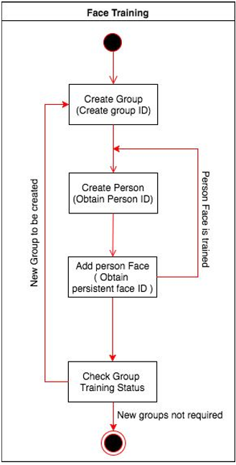

*FIG 2.2: flow chart of proposed model*

**2.4 CONSTRAINTS AND ASSUMPTIONS**

Assumption are as follows:

Number of nodes –Nodes represent total number of sensors used in a building.

Transmission range ($T_{x}$ R)- It is the maximum distance up to which the sensor can transmit the data. It may vary from node to node.

Path Loss Exponent-It is the reduction in energy density of a node as it transmits data through space. Path loss may occur due to many affects such as free space loss, refraction, diffraction.It can be written as: $\boxed{E_{tx} (m,d)∝md^{n}}$

here m=number of bits, d= distance between nodes, n=path loss exponent.

Usually, 2 $≤n≤$ 6. Here we are taking n=3.

Neighbour Density-it defines the number of nodes present in the neighbourhood of the source node.

Lifetime- it is defined as the time till the first node dies out (from the point of deployment).It is given as L=t’-t

Where,t’=final time and t=initial time.

# CHAPTER 3

# EXTERNAL INTERFACE REQUIREMENTS

# 3.1 USER INTERFACES

In user interface we define user, task, environment analysis and describe the external and internal components and the architecture of user interface with some rough pictorial views of the user interface and its components.

Here we are going to make a software which will help teachers and students by efficiently taking their attendance rather than the conventional methods of marking attendance. This interface will be easy to use and student’s attendance will be uploaded directly into their attendance portals.

# 3.2 HARDWARE INTERFACES

For implanting the current code (i.e. of phase 1), we are doing simulation to find which protocol we are going to use, for this MATLAB is being used and we need the following hardware interfaces (windows specific) for the same:

* Operating Systems: Windows 10, Windows Service Pack 1, Windows Server 2019, Windows Server 2016.
* Processors: Any Intel or AMD x86-64 processor(minimum), Any Intel or AMD x86-64 processor with four logical cores and AVX2 instruction set support(recommended)
* Disk: 2.9 GB of HDD space for MATLAB only, 5-8 GB for a typical installation(minimum)
* RAM: 4GB (minimum), 6GB(Recommended)
* Graphics: No specific graphics card is required.

# 3.3 SOFTWARE INTERFACES

This application is using MATLAB for simulating the different protocols we will be using to send the details of attendance from classrooms in various buildings of the campus to the cloud server. Then based on the real-time results of the working of these protocols we’ll be using the one which is best suitable for application.

MATLB is a multi-paradigm numerical computing environment; it is intended primarily for numerical computing. It also has tightly integrated graph-plotting features. MATLAB can call functions and subroutines written in the programming languages C or Fortran.

# 3.4 COMMUNICATION INTERFACES

# The communication interface used here is attendance monitoring using face recognition through IOT and for deploying this we are using various sensors installed in buildings. Then the data will be sent to cloud server through various protocols.

**CHAPTER 4**

**SYSTEM FEATURES**

**4.1 CODE SNIPPET**

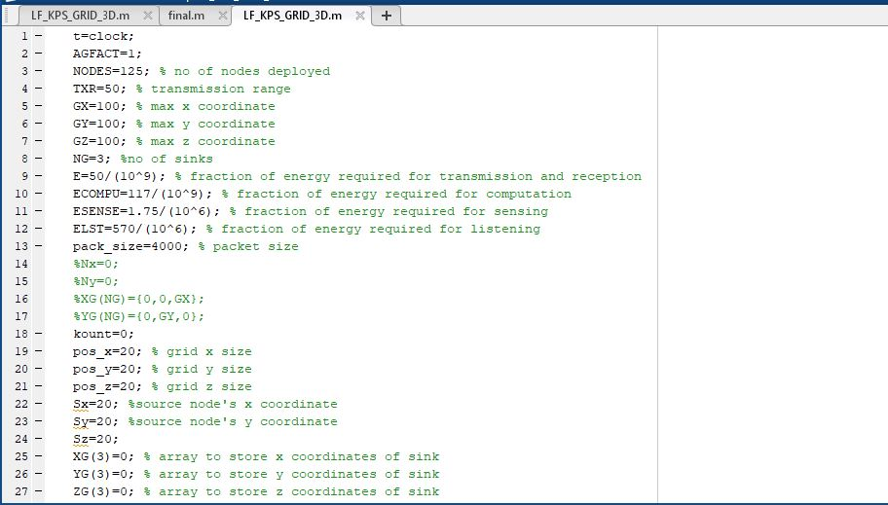

*FIG 4.1:Code snippet*

**4.2 OUTPUT**

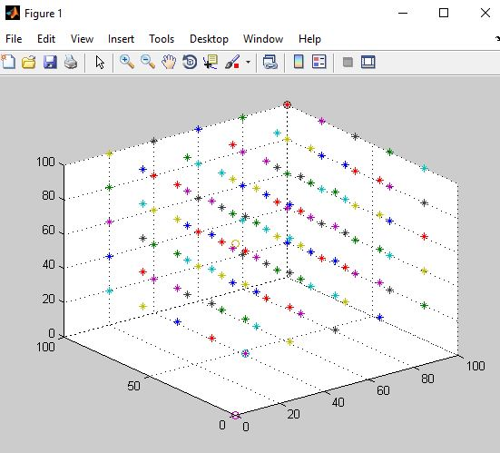

*FIG 4.2: Output*

**4.3 NODE DEPLOYMENT**

Sensors nodes generates huge amount ofsimilar packets, data aggregation is used to reduce the transmission of similar packets. Data aggregation is combination of information from different sensor nodes by applying functions like suppression, average, maximum. The routing protocol incorporates this data aggregation technique to reduce data redundancy and achieve energy efficiency.

In WSN motes are deployed according tothe demand of the application. Thus affects the productivity of the routing protocol. The nodes are deployed in uniform way or randomized way. In uniform way, the nodes are placed manually at fixed spot and routing paths are predetermined. In randomized way, the nodes are scattered randomly. This causes several issues such as optimal clustering, coverage etc. The position of the sink node or cluster head is an important factor in terms of energy efficiency. Data transfer through these one node to another in wireless network in face recognition in a randomized way.

**4.4 MATLAB**

This section describes hardware and software requirements for running the MATLAB software.

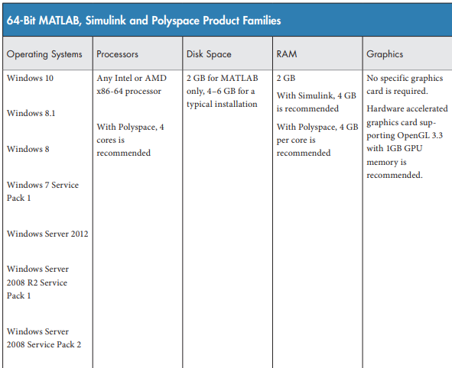

*FIG 4.3: System Requirements For MATLAB*.

**CHAPTER 5**

**OTHER NONFUNCTIONAL REQUIREMENTS**

**5.1 PERFORMANCE REQUIREMENTS**

We use Face Recognition Techniques to recognize students. The knowledge of presence of students may help in more regular sessions. This would definitely give better results not only in terms of marks but also in terms of knowledge. If students learn regularly then only can they be effective to themselves. We want to convey that when sessions are held regularly, they are for our own good and our project would be a working model towards our motive.

This project deals with marking a student present or absent on the basis of his identification from the pre-loaded dataset. If the attendance is marked by a trained machine, which consist of a particular dataset, it becomes quite a difficult task to escape from it. The student has to appear in front of it to mark himself present for a particular session. This project aims for a collected data set, which would identify faces using Face Recognition Techniques and generating attendance on an excel sheet simultaneously. The output thus generated gives us an attendance sheet with students marked present or absent. This output can then be used by the respective authority to take corrective measures to improve such irregularities.

**5.2 SAFETY REQUIREMENTS**

In today’s life, an increased absence of students from class is quite a common scene. This leads to fatal consequences for a student as well as a teacher such as-

* Incomplete syllabus
* Irregular sessions
* Unfruitful sessions
* Waste of time of those who are interested to gain knowledge

Our project titled –**Face Recognition on e-attendance**, helps in improving this irregular strength of students in class.

Several factors leads to development of such irregular behavior. This has become an unavoidable tendency in most classes and sessions. This when prolonged, affects not only the concern’s marks but also his related mates and teachers. Therefore, it is essential to have a mark of students and not let them take advantages of the loopholes provided unintentionally.

**5.3 SECURITY REQUIREMENTS**

Face recognition security is about using a human face as a security code or key. Face recognition security works with faceprints and identify eight nodal points on the face of an individual. Face recognition security system allows authenticated user to mark the attendance in the excel sheet. Using a human face as a key and match with the dataset created by the user by capturing his image from different angles and if the face matches with the dataset then mark the attendance in a excel sheet.

**5.4 SOFTWARE QUALITY ATTRIBUTES**

Our webcam is used as the camera source. So, it captures images, creates dataset and identifies the faces. Students are asked to sit in front of the camera for a particular time and give different face expressions and angles so as to obtain a data set with vivid images. The lighting is kept such that it is neither too dim nor too bright. The data set created contains gray images. The webcam records a video out of which fixed number of images are extracted to create an image data set. The collected data set is then trained. This trained data set is then further processed by a recognizer so that our model recognizes each face. As soon as the recognizer starts working it simultaneously starts marking attendance in an excel sheet. An excel attendance sheet is thus obtained as the output.

# CHAPTER 6

# CONCLUSION AND FUTURE WORK

# 6.1 CONCLUSIONS

# A system for automating the process of attendance has been proposed using IOT technology and face recognition (image processing).The proposed system can prove to be utilitarian for not only academic institutions but also in other professional environments.

# 6.2 SCOPE FOR FUTURE WORK

The attendance data collected could be used later to find various statistical relation with respect to the student performance. The project can be extended in other interesting ways, such as implementation of system for security access, dynamic face detection in public places.

The whole system can be improved by increasing the efficiency of the face detection algorithms used. It can further be improved to automatically calculate the attendance percentage of the students and intimate the teachers and parents if a student’s attendance is below a certain percentage.

**REFRENCES**

1. <http://www.ijarcce.com/upload/2016/si/ICRITCSA-16/IJARCCE-ICRITCSA%203.pdf>
2. Mahesh Sutaret al, “Smart Attendance System using RFID in IOT”, International Journal of Advanced Research in Computer Engineering & Technology (IJARCET) Volume 5, Issue 4, April 2016
3. M. NewlinRaajkumar et al, “Efficient and portable fingerprint based attendance system using geo sensor”, International Journal of Advanced Research in Biology Engineering Science and Technology (IJARBEST), Vol. 2, Special Issue 10, March 2016
4. Ankita Agrawal et al, “Online Attendance Management System Using RFID with Object Counter, International Journal of Information and Computation Technology.ISSN 0974-2239 Volume 3, Number 3 (2013), pp. 131-138
5. Riya Lodhaa et al, “Bluetooth Smart based Attendance Management System”, International Conference on Advanced Computing Technologies and Applications (ICACTA-2015) 22 [6] Josphineleela.R and M.Ramakrishnan, “An Efficient Automatic Attendance System Using Fingerprint Reconstruction Technique”, (IJCSIS) International Journal of Computer Science and Information Security, Vol. 10, No. 3, March 2012

“Internet of Things - A Hands-on-Approach”, 1st Edition by Vijay Madisetti and ArshdeepBahga.